PRE-MODEL EXAM

Name: T. Jithendra

Register Number: 192111521

Course Code: DSA0163

Course Name: Object Oriented

Programming with c++

SET – C

Person:

#include<iostream>

using namespace std;

class Person{

private:

string name;

int age;

string country;

public:

Person (string n,int a,string c){

name = n;

age = a;

country = c;

}

string getname(){

return name;

}

int getage(){

return age;

}

string getcountry(){

return country;

}

void display(){

cout << "Name: " << name << endl;

cout << "Age: " << age << endl;

cout << "Country: " << country << endl;

}

};

int main(){

Person person("Jithu", 20, "India");

person.display();

return 0;

}

Output:

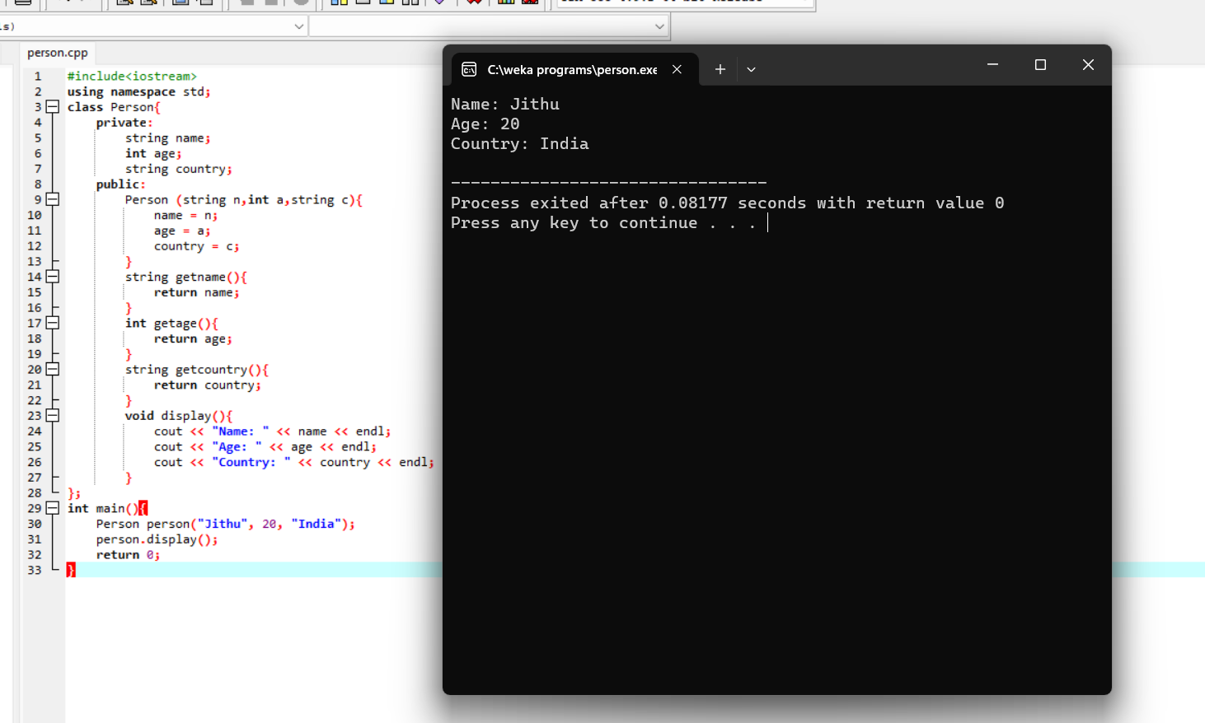

Rectangle:

#include<iostream>

using namespace std;

class Rectangle{

private:

double length;

double breadth;

public:

Rectangle(){

length = 0;

breadth = 0;

}

Rectangle(double length, double breadth){

length = length;

breadth = breadth;

}

Rectangle(double side){

length = side;

breadth = side;

}

double calculatearea(){

return length \* breadth;

}

};

int main(){

Rectangle r1;

Rectangle r2(15, 16);

Rectangle r3(75);

cout << "Area of the rectangle 1: " << r1.calculatearea() << endl;

cout << "Area of the rectangle 2: " << r2.calculatearea() << endl;

cout << "Area of the rectangle 3: " << r3.calculatearea() << endl;

return 0;

}

Output:

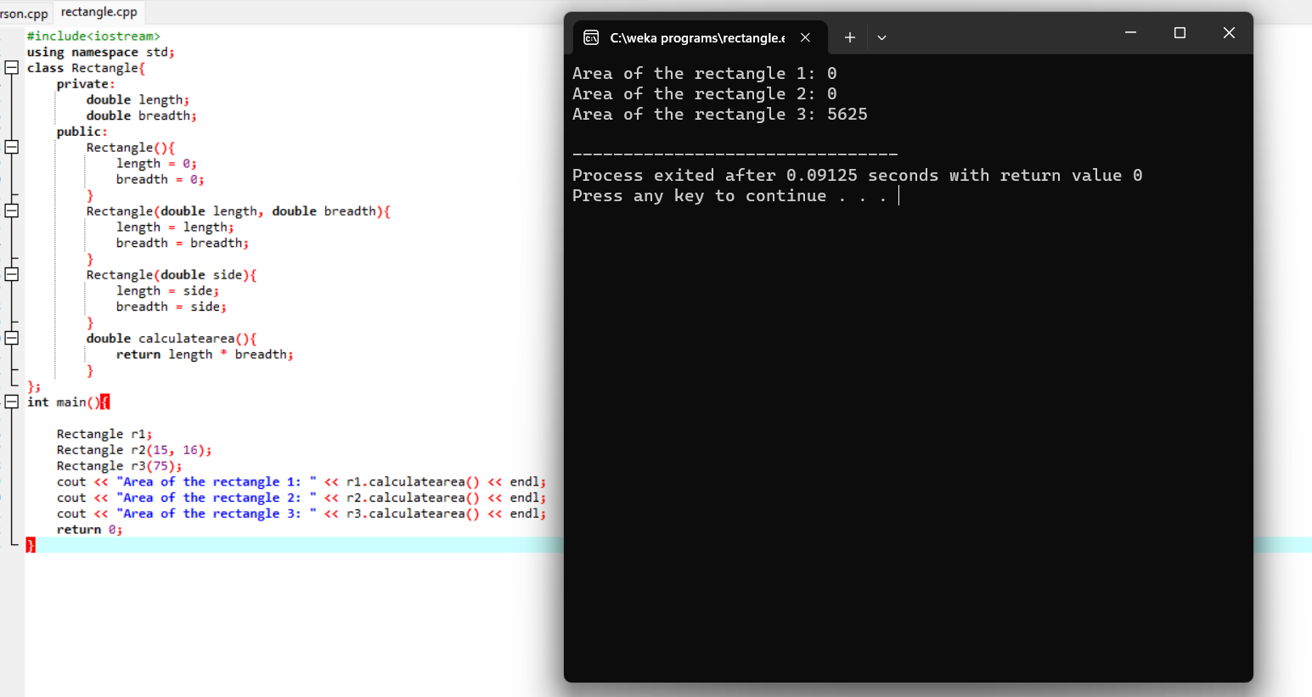

Pattern:

#include<iostream>

using namespace std;

int main(){

int n;

cout << "enter the number o frows to be printed : ";

cin >> n;

for (int i=1;i<=n;i++){

for (int j=1;j<=i;j++){

cout << "1";

}

cout << endl;

}

return 0;

}

Output:

